**bibliographic Information ツ**

Author(s):

Title of **article** or **book** (if a chapter in a book, put the chapter # and title here, and put the title of the book in “Title of publication”):

Tis the book

Title of publication, including Vol., Num., date (if article in magazine, newspaper, or journal):

Page numbers (if article in magazine, newspaper, or journal):

Publisher:

Date published:

URL (if applicable):

MLA citation:

**Chapter 1. Intro:**

**Direct quotes: *Include Page #s***(For each quote, provide some context and/or analysis; you may also want to re-state the information in your own words. Quotes from your sources, and your understanding of them, will make up the bulk of your literature review)

1. 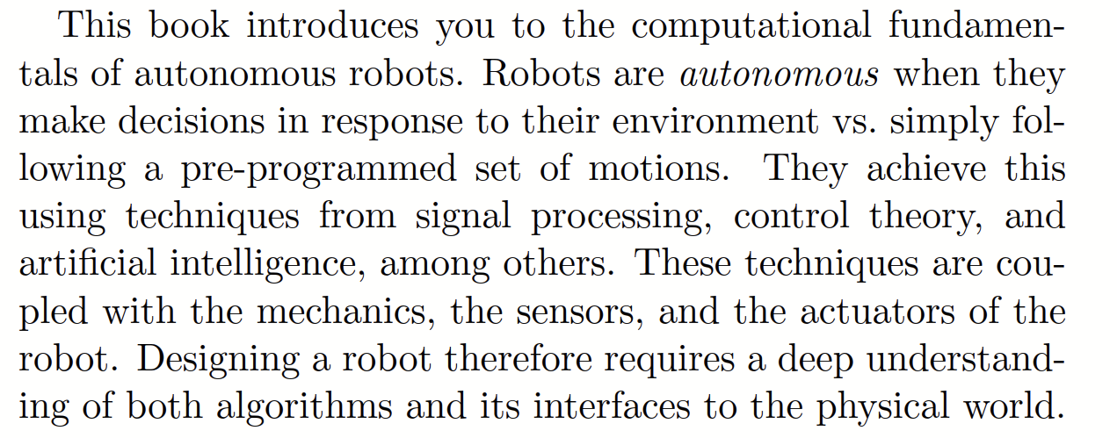p13
2. 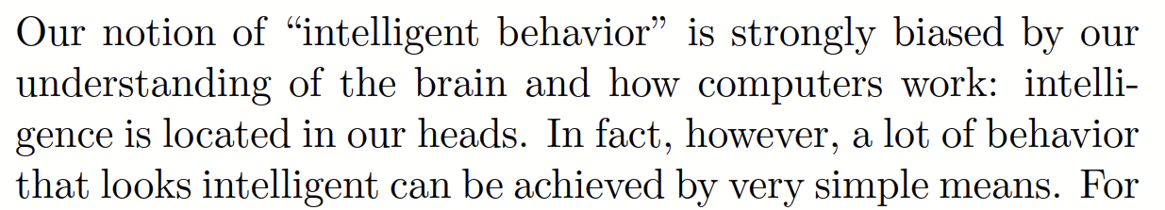p14
3. 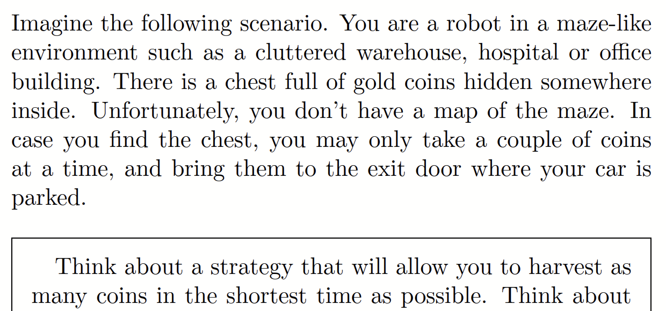p15-16
4. 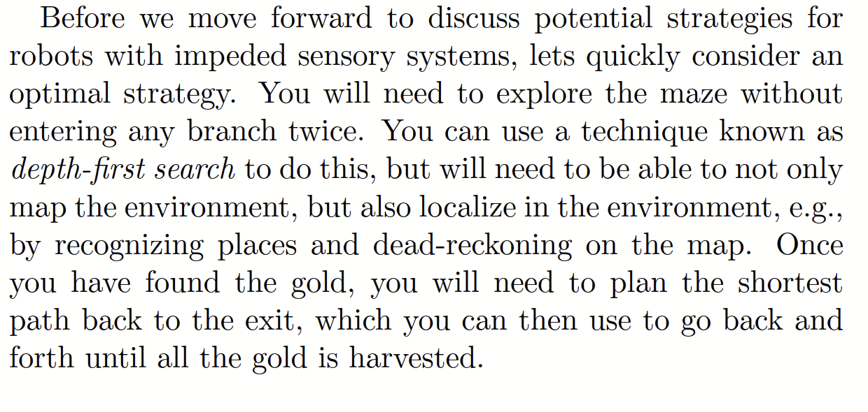p16
5. 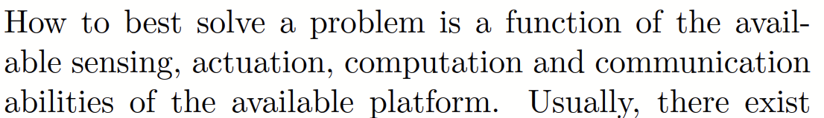p19

**Notes, Summary, Conclusions, etc.**

Oh my god. Actual good definitions for everything. I don’t have to keep using the roomba example. It gives amazing examples and ways to understand what SLAM and all of the basics of it are.

**Chapter 2. Locomotion and Manipulation:**

**Direct quotes: *Include Page #s***(For each quote, provide some context and/or analysis; you may also want to re-state the information in your own words. Quotes from your sources, and your understanding of them, will make up the bulk of your literature review)

1. 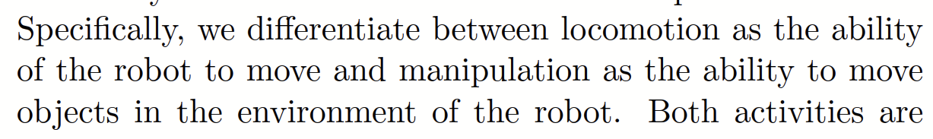p23
2. 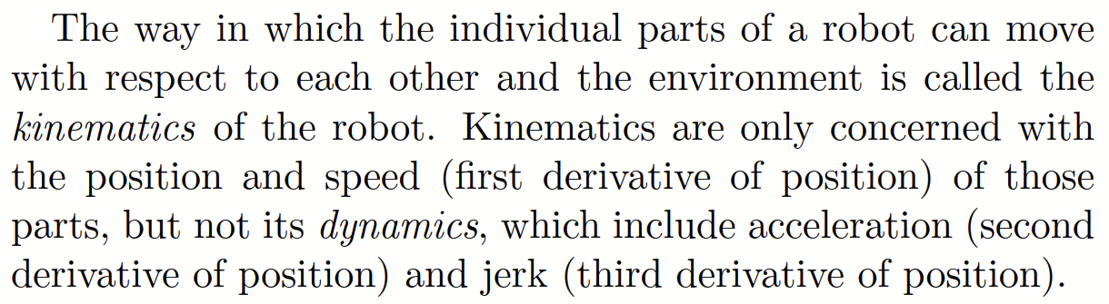p24
3. 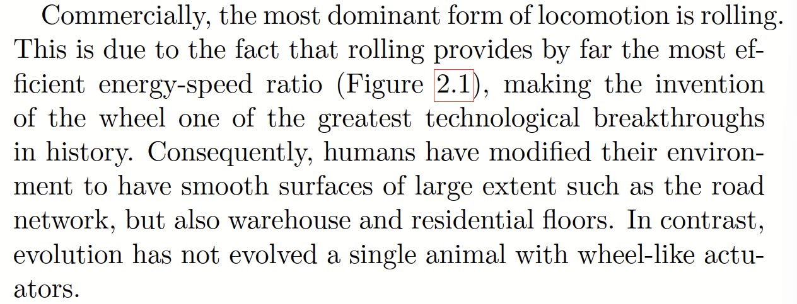p24
4. 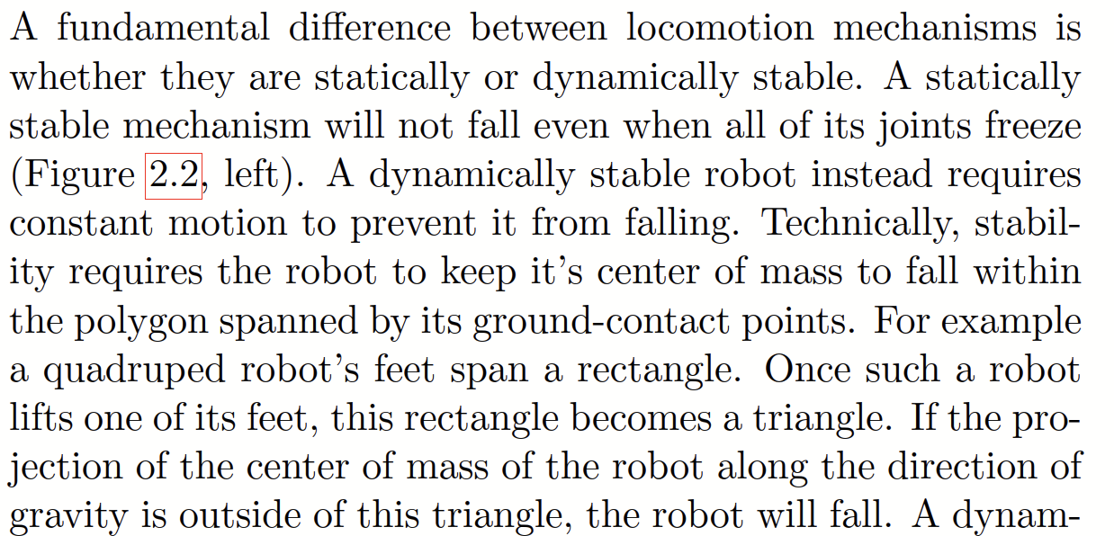p26
5. 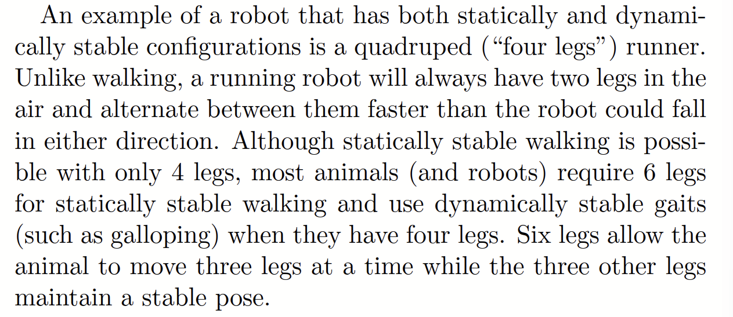p27
6. 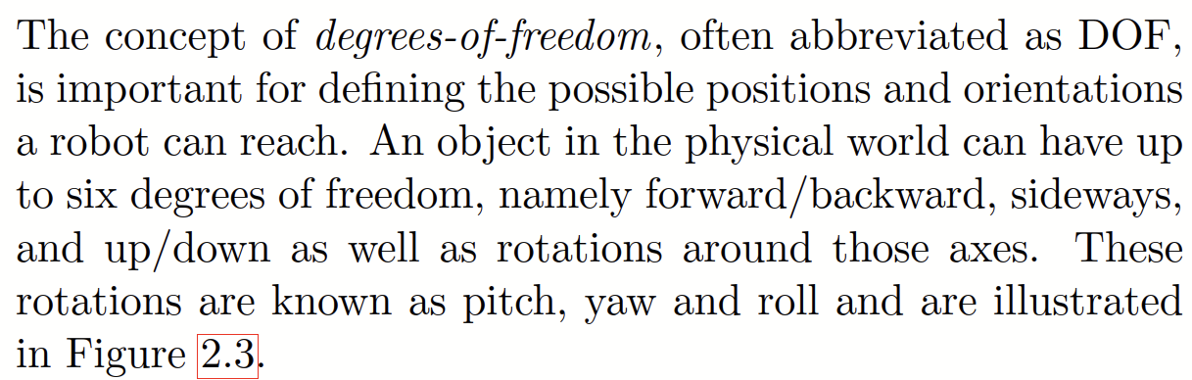p27

**Notes, Summary, Conclusions, etc.**

Again, more definitions, stuff I already know.

**Chapter 3. Forward and Inverse Kinematics:**

**Direct quotes: *Include Page #s***(For each quote, provide some context and/or analysis; you may also want to re-state the information in your own words. Quotes from your sources, and your understanding of them, will make up the bulk of your literature review)

1. 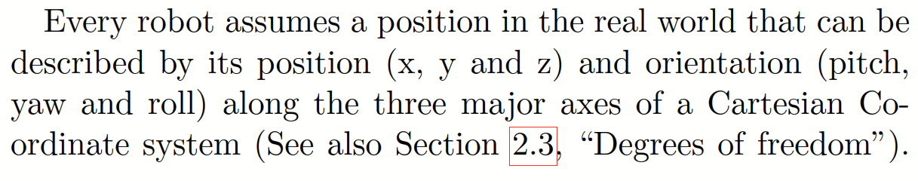p35
2. 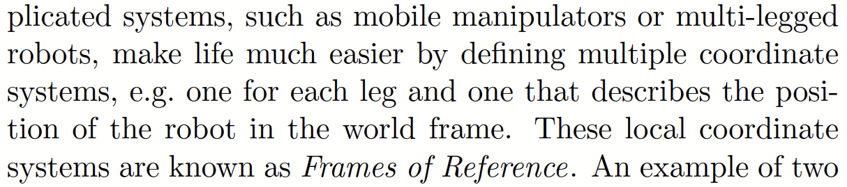p37
3. 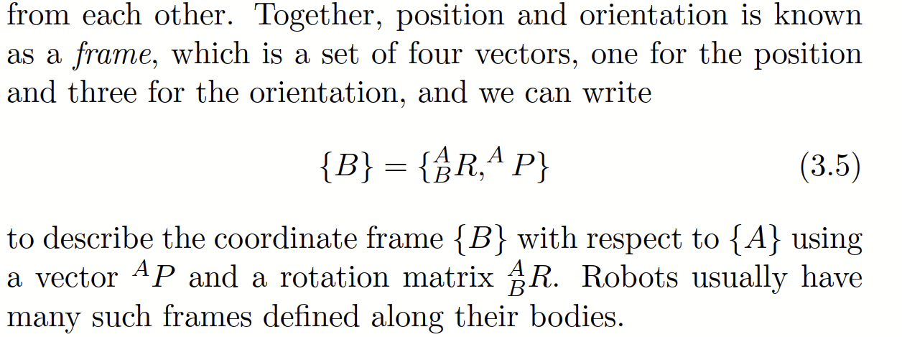p40
4. 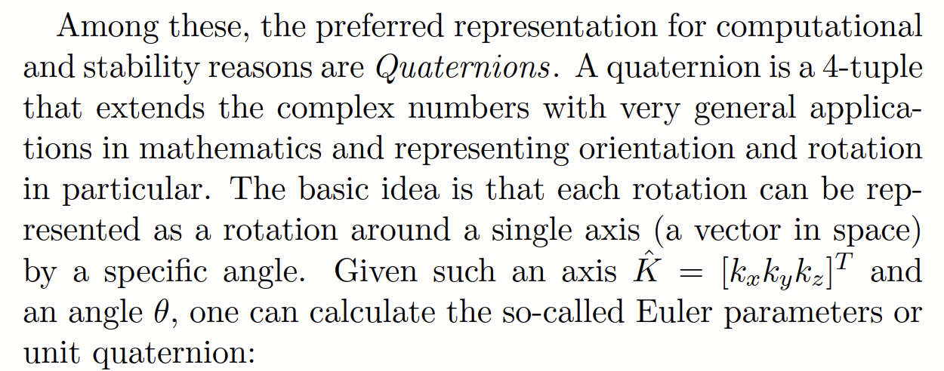p43 BOOOOOOO
5. 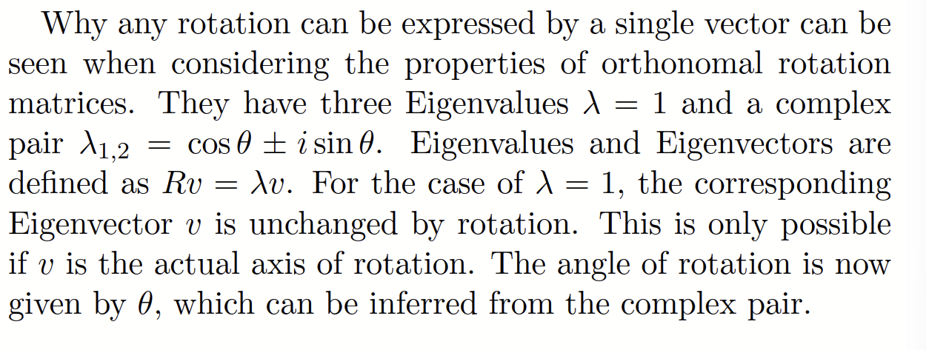p44 BOOOO pt2
6. 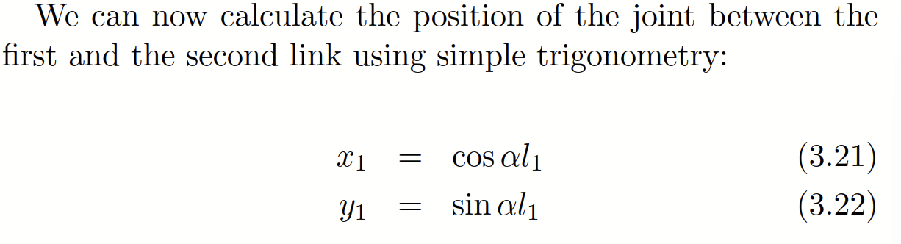p45 YAYYYYYYY
7. 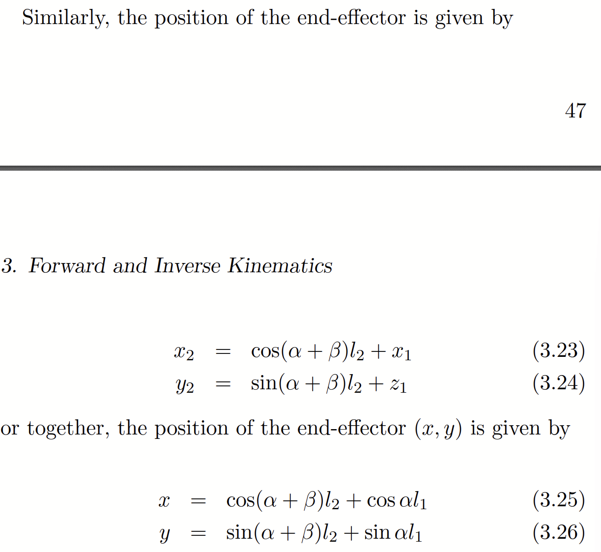p46 YAAAAAYYYYY pt 2
8. 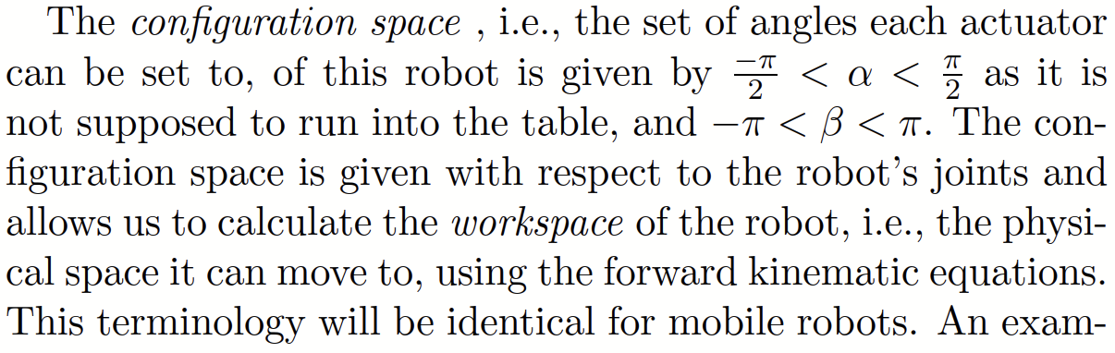p46 meh
9. 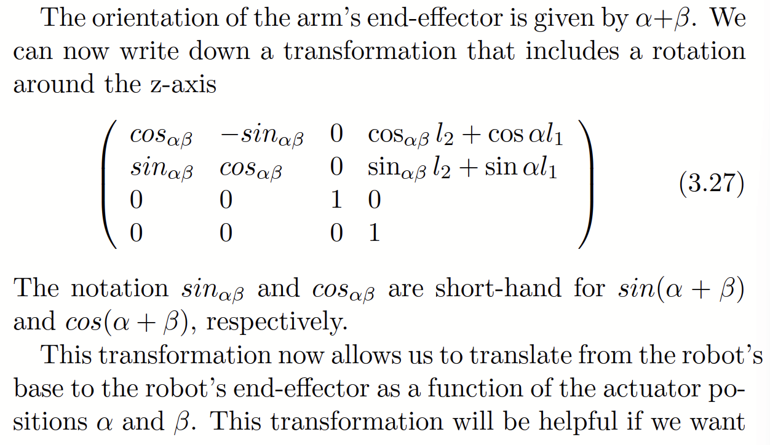p46 booooooo
10. 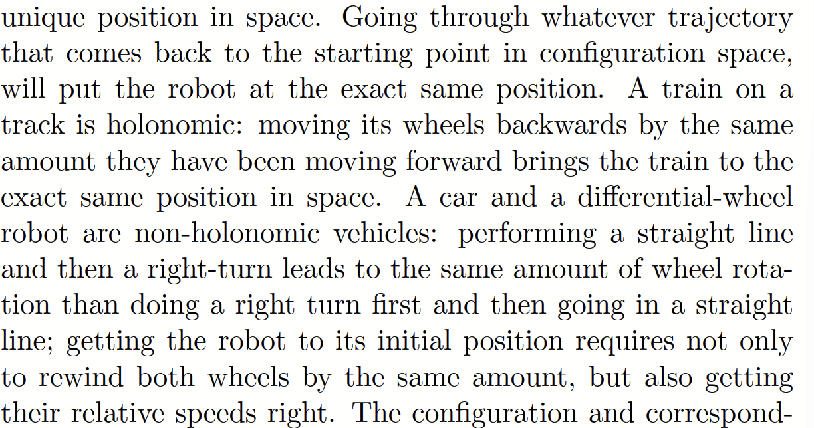p48
11. 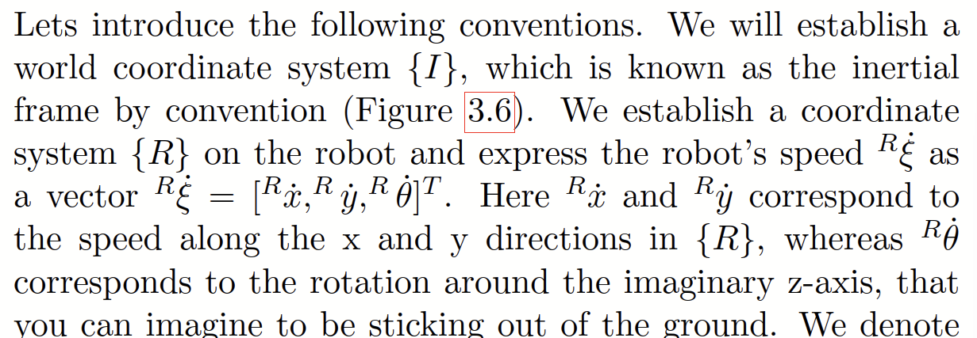p48
12. 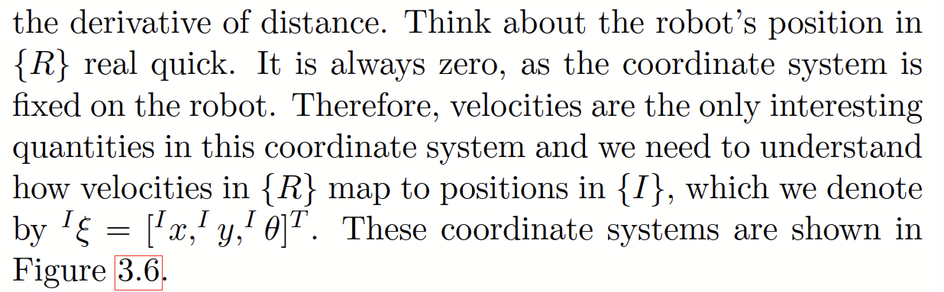p49
13. 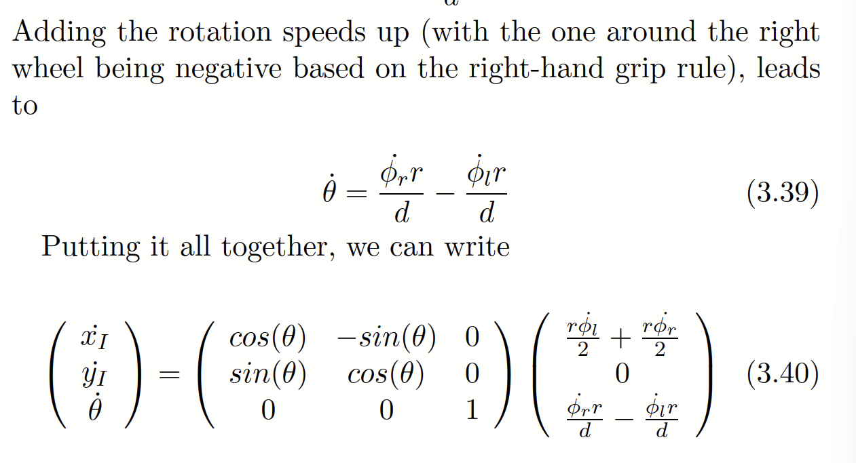p52
14. 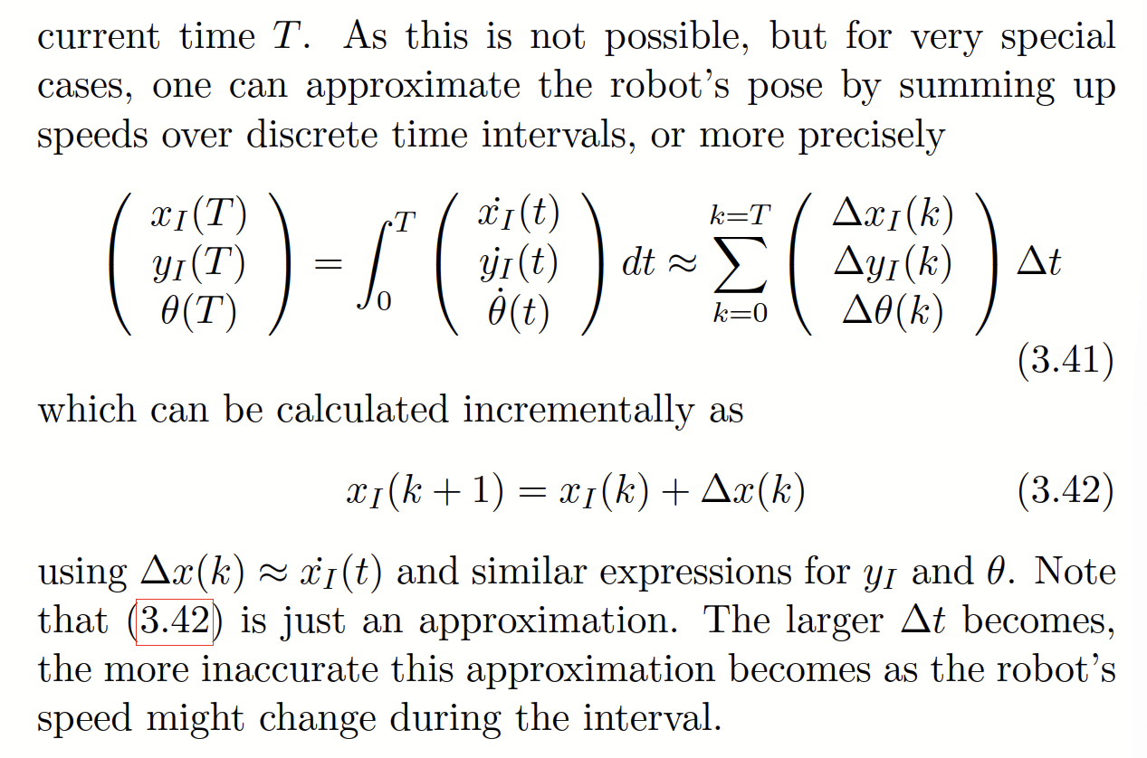p53
15. 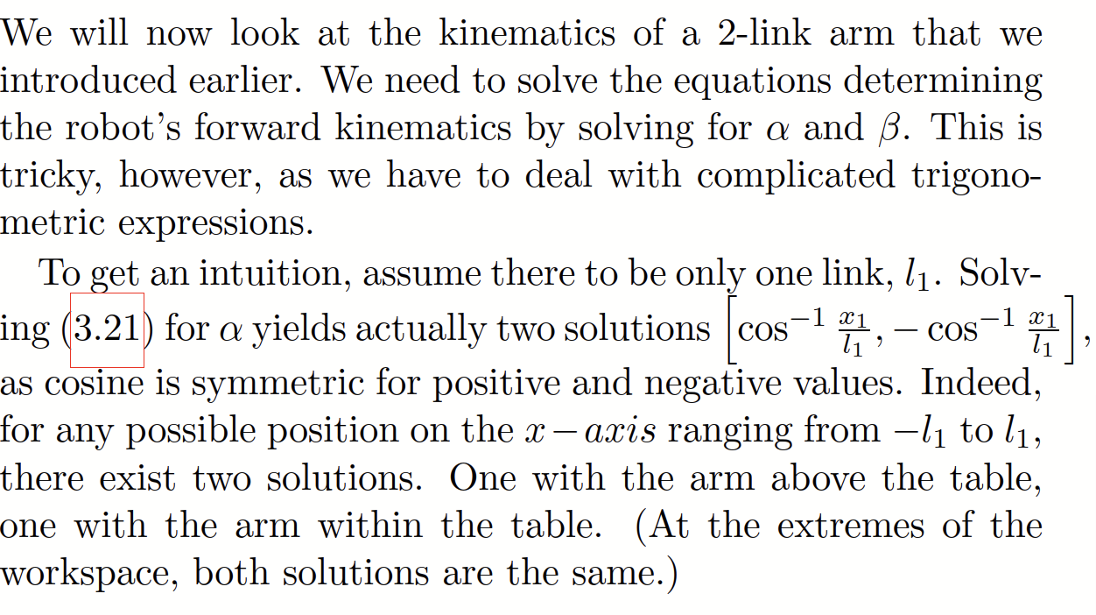p59
16. 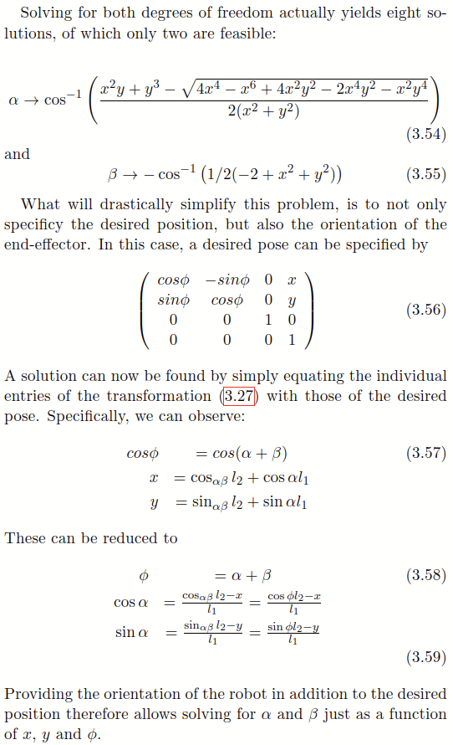p60

**Notes, Summary, Conclusions, etc.**

**Chapter 4. Path Planning:**

**Direct quotes: *Include Page #s***(For each quote, provide some context and/or analysis; you may also want to re-state the information in your own words. Quotes from your sources, and your understanding of them, will make up the bulk of your literature review)

1. 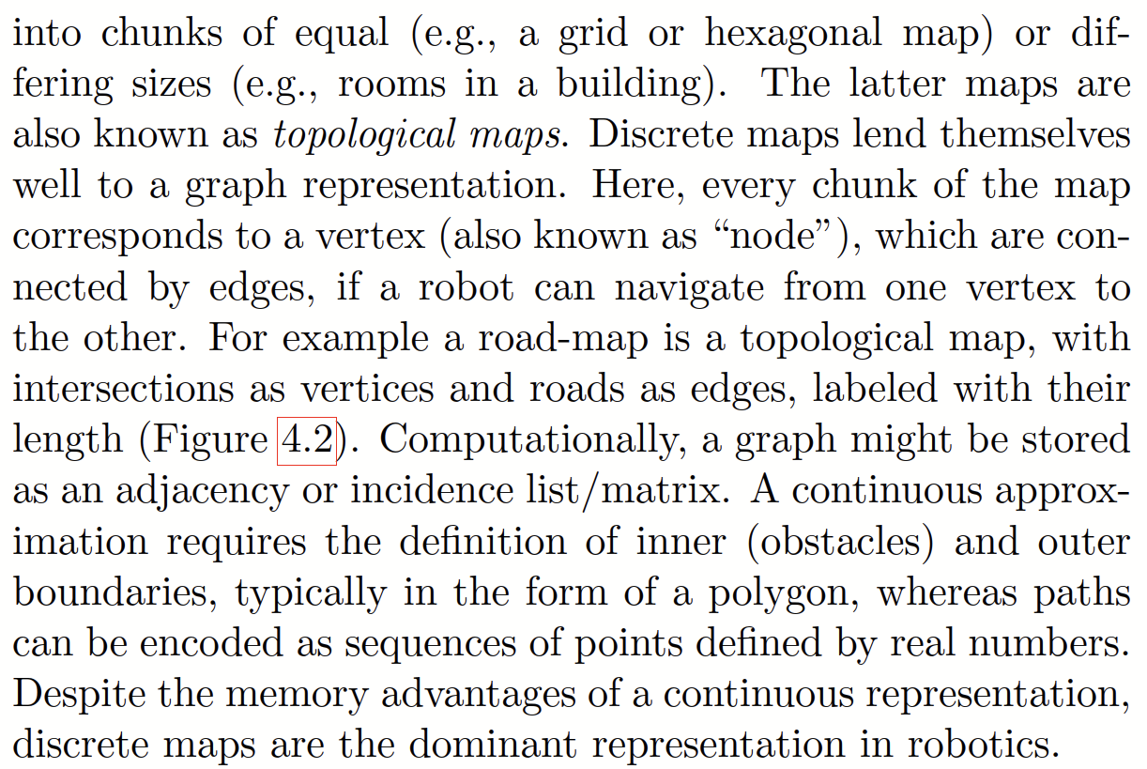**p72**
2. 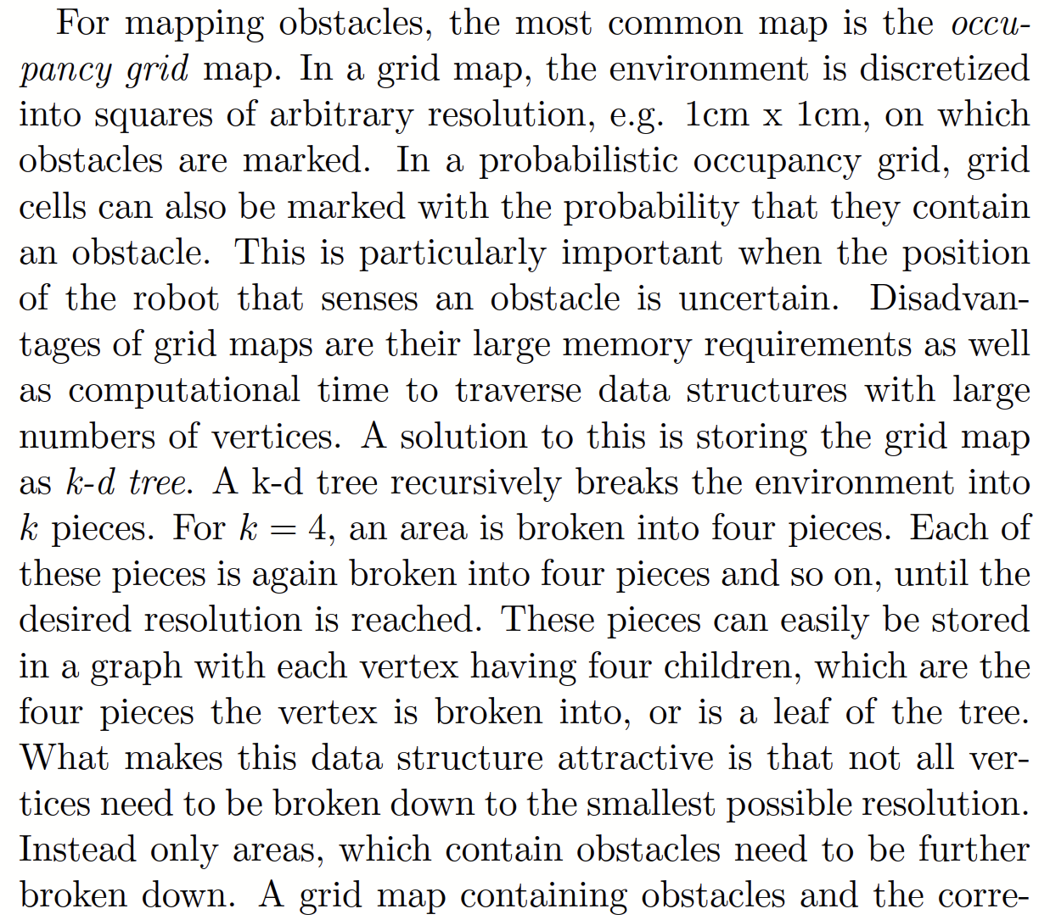**p72**
3. 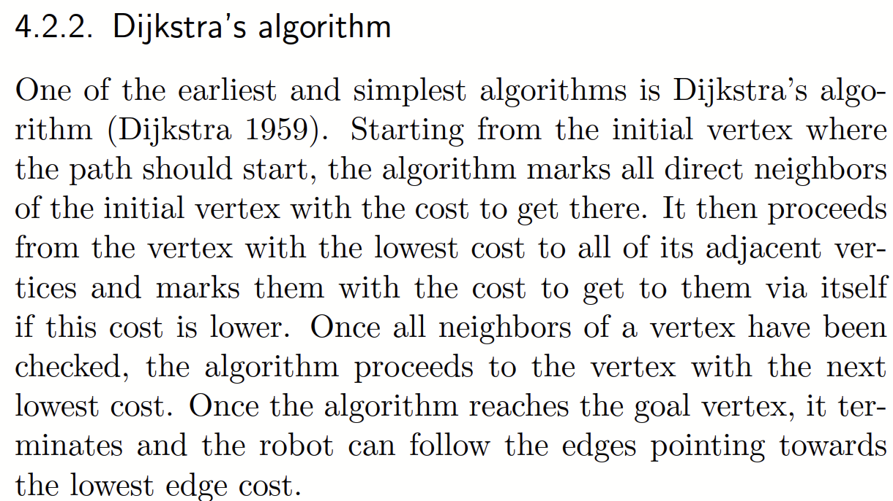**p75**
4. 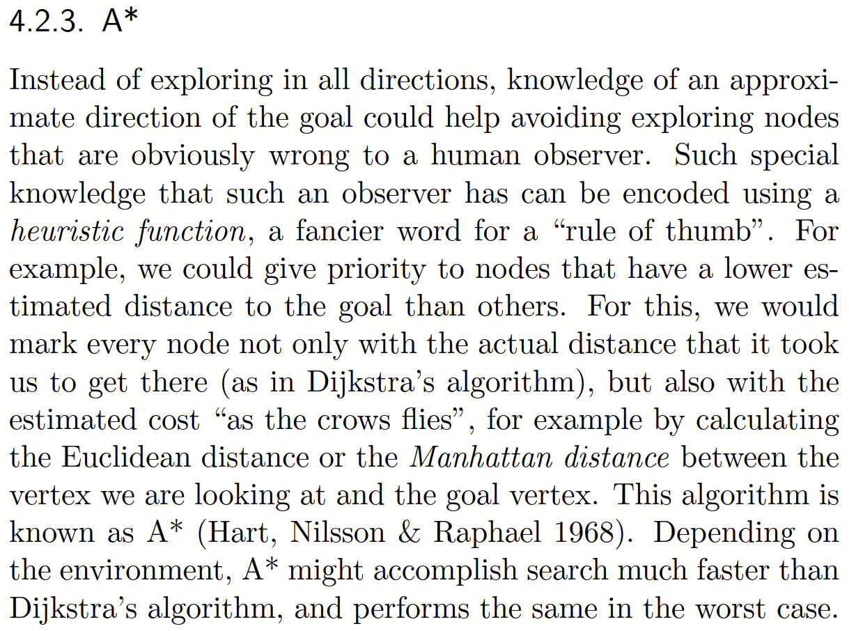**p76**
5. 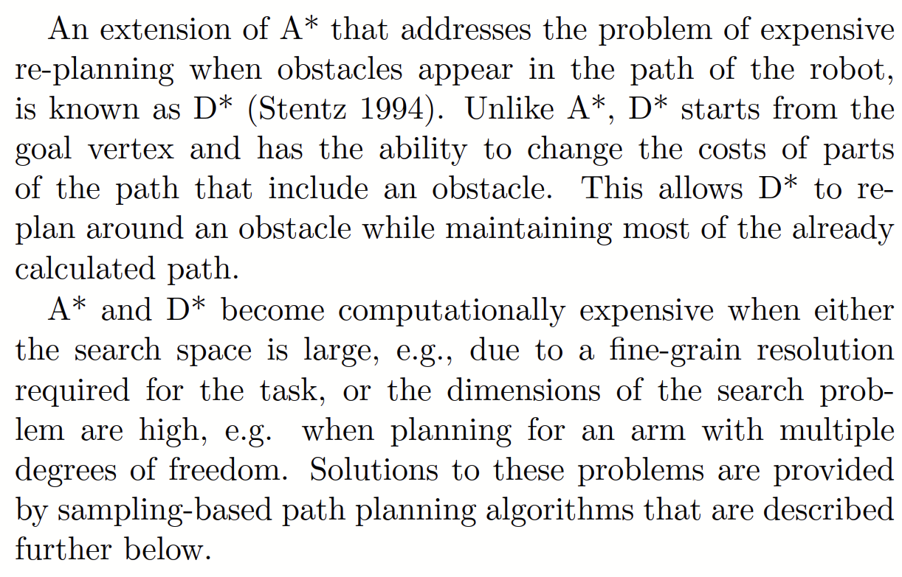**p77**
6. 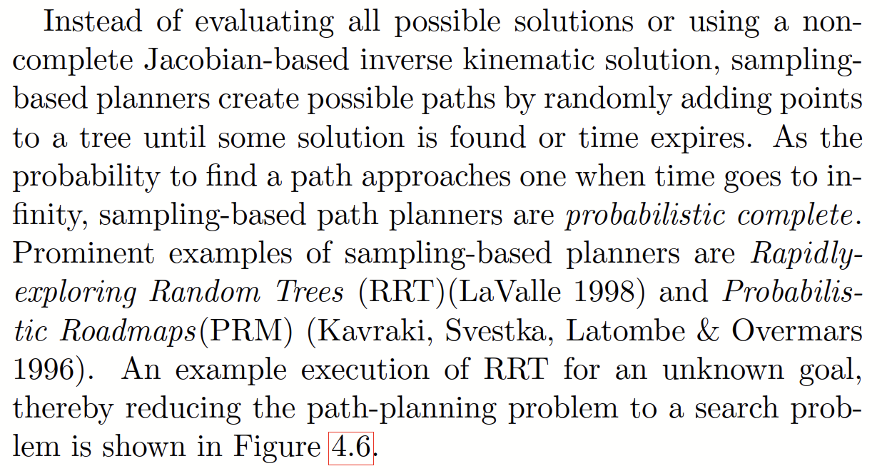**p78**

**Notes, Summary, Conclusions, etc.**

Path planning is kindof a pain in the ass, and there are a lot of different ways to tackle it.

**Chapter 5:**

**Direct quotes: *Include Page #s***(For each quote, provide some context and/or analysis; you may also want to re-state the information in your own words. Quotes from your sources, and your understanding of them, will make up the bulk of your literature review)

1. “The development of sensors is classically driven by industries other than robotics. These include submarines, automatically opening doors, safety devices for industry, servos for remote- controlled toys, and more recently the cell-phone, automobiles and gaming consoles. These industries are mostly responsible for making “exotic” sensors available at low cost by identifying mass-market applications, e.g., accelerometers and gyroscopes now being used in mass-market smart phones or the 3D depth sensor “Kinect” as part of its XBox gaming console.” p 89
2. “Proprioception refers to the perception of internal states of a robot. This is diﬀerent from exteroception, which describes sensing of anything outside of the robot. Proprioception includes awareness of the robot’s joint angles, its speeds, as well torques and forces.” p 91
3. “Instead of using line patterns, infrared-based depth image sensors use a speckle pattern (a collection of randomly distributed dots with varying distances), and two computer vision concepts: depth from focus and depth from stereo. When using a lens with a narrow focal depth, objects that are closer or farther away appear blurred (you can easily observe this on professional portrait photos, which often use this eﬀect for aesthetic purposes). Measuring the “bluriness” of a scene (for known camera parameters) therefore allows for an initial estimate of depth. Depth from stereo instead works by measuring the disparity of the same object appearing in two images taken by cameras that are a known distance apart. Being able to identify the same object in both frames allows to calculate this disparity, and from there the distance of the object. (The farther the object is away, the smaller is the disparity.) This is where the speckle pattern comes in handy, which simply requires to search for blobs with similar size that are close to each other.” p 94
4. “An accelerometer can be thought of as a mass on a dampened spring. Considering a vertical spring with a mass hanging down from it, we can measure the acting force F = kx (Hooke’s law) by measuring the displacement x that the mass has stretched the spring. Using the relationship F = am, we can now calculate the acceleration a on the mass m.” p 97
5. “A gyroscope is an electro-mechanical device that can measure rotational orientation. It is complementary to the accelerometer that measures translational acceleration. Classically, a gyroscope consists of a rotating disc that could freely rotate in a system of pivots and gimbals. When moving the system, the inertial momentum keeps the original orientation of the disc, allowing to measure the orientation of the system relative to where the system was started. A variation of the gyroscope is the rate gyro, which measures rotational speed.” p 98

**Notes, Summary, Conclusions, etc.**

Sensors do exist

**Chapter 7 (Feature Extraction):**

**Direct quotes: *Include Page #s***(For each quote, provide some context and/or analysis; you may also want to re-state the information in your own words. Quotes from your sources, and your understanding of them, will make up the bulk of your literature review)

1. “A robot can obtain information about its environment by both active (e.g., ultra-sound, light, and laser) or passive sensing (e.g., acceleration, magnetic ﬁeld, or cameras). There are only few cases where this information is directly useful to a robot.Before being able to arrive at semantic information such as “I’m in the kitchen”, “this is a cup” or “this is a horse”, is identifying higher-level features.” p 117
2. “The information generated by sensors can be quite formidable. For example, a simple webcam generates 640x480 color pixels (red, green and blue) or 921600 Bytes around 30 times per second. A single-ray laser scanner still provides around 600 distance measurements 10 times per second.” p 117
3. “A desirable property of a feature is that its extraction is repeatable and robust to rotation, scale, and noise in the data. We need feature detectors that can extract the same feature from sensor data, even if the robot has slightly turned or moved farther or closer to the feature.” p 118
4. “A laser scanner or similar device pointed against a wall will return a suite of N points at position (xi, yi) in the robot’s coordinate system. These points can also be represented in polar coordinates (ρi, θi). We can now imagine a line running through these points that is parametrized with a distance r and an angle α. Here, r is the distance of the robot to the wall and α its angle. As all sensors are noisy, each point will have distance di from the “optimal” line running through the points.” p 119

**Notes, Summary, Conclusions, etc.**

Turns out its hard to get things out of sensors

**Chapter 8 (Uncertianty):**

**Direct quotes: *Include Page #s***(For each quote, provide some context and/or analysis; you may also want to re-state the information in your own words. Quotes from your sources, and your understanding of them, will make up the bulk of your literature review)

1. “Robots are systems that combine sensing, actuation, computation, and communication. Except for computation, all of its sub-systems are subject to a high degree of uncertainty. This can be observed in daily life: phone calls often are of poor quality, making it hard to understand the other party, characters are diﬃcult to read from far away, the front wheels of your car slip when accelerating on a rainy road from a red light, or your wireless device has a hard time getting a connection. In robotics, measurements taken by on-board sensors are sensitive to changing environmental conditions and subject to electrical and mechanical limitations. Similarly, actuators are not accurate as joints and gears have backlash and wheels do slip. Finally, communication, in particular, wireless either via radio or infrared, is notoriously unreliable.” p 129
2. “It turns out that the Gaussian Distribution is very appropriate to model prominent random processes in robotics: the robot’s position and distance measurements. A diﬀerential wheel robot that drives along a straight line, and is subject to slip, will actually increase its uncertainty the farther it drives. Initially at a known location, the expected value (or mean) of its position will be increasingly uncertain, corresponding to an increasing variance. This variance is obviously somehow related to the variance of the underlying mechanism, namely the slipping wheel and (comparably small) encoder noise. Interestingly, we will see its variance grow much faster orthogonal to the robot’s direction, as small errors in orientation have a much larger eﬀect than small errors in longitudinal direction.” p 130
3. “The key intuition behind the error propagation law is that the variance of each component that contributes to a random variable should be weighted as a function of how strongly this component inﬂuences this random variable. Measurements that have little eﬀect on the aggregated random variable should also have little eﬀect on its variance and vice versa. “How strongly” something aﬀects something else can be expressed by the ratio of how little changes of something relate to little changes in something else.” p 131

**Notes, Summary, Conclusions, etc.**

I AM IGNORING ODOMETRY CUZ ITS JUST THE RAW MATH AND I HATE THIS

**Chapter 9 (Localization):**

**Direct quotes: *Include Page #s***(For each quote, provide some context and/or analysis; you may also want to re-state the information in your own words. Quotes from your sources, and your understanding of them, will make up the bulk of your literature review)

1. “In other words, the law of total probability requires us to consider all possible locations the robot could have ever been at. This step is known as Action Update. In practice we don’t need to calculate this for all possible locations, but only those that are technically feasible given the maximum speed of the robot.” p 144
2. “We have now learned two methods to update the belief distribution of where the robot could be in the environment. First, a robot can use external landmarks to update its position. This is known as perception update and relies on exteroception. Second, a robot can observe its internal sensors. This is known as action update and relies on proprioception. The combination of action and perception updates is known as Markov Localization. You can think about the action update to increase the uncertainty of the robot’s position and the perception update to shrink it.” p 144-145
3. “Instead of using a coarse topological map, we can also model the environment as a ﬁne-grained grid. Each cell is marked with a probability corresponding to the likelihood of the robot being at this exact location” p 147
4. “Although grid-based Markov Localization can provide compelling results, it can be computationally very expensive, in particular when the environment is large and the resolution of the grid is small. This is in part due to the fact that we need to carry the probability to be at a certain location forward for every cell on the grid, regardless of how small this probability is.” p149
5. “The location of a robot is subject to uncertainty due to wheel- slip and encoder noise. We learned in the past how the variance in position can be derived from the variance of the robot’s drive train using the error propagation law and the forward kinemat- ics of the robot. One can see that this is error is continuously increasing unless the robot has additional observations, e.g., of a static object with known location. This update can be formally done using Bayes’ rule, which relates the likelihood to be at a certain position given that the robot sees a certain feature to the likelihood to see this feature at the hypothetical location. For example, a robot that drives towards a wall will become less and less certain of its position (action update) until it encoun- ters the wall (perception update). It can then use its sensor model that relates its observation with possible positions. Its real location must be therefore somewhere between its original belief and where the sensor tells it to be. Bayes’ rule allows us to perform this location for discrete locations and discrete sensor error distributions. This is inconvenient as we are used to represent our robot’s position with a 2D Gaussian distribution. Also, it seems much easier to just change the mean and variances of this Gaussian instead of updating hundreds of variables” p 150
6. “In order to localize a robot using a map, we need to perform the following steps 1. Calculate an estimate of our new position using the for- ward kinematics and knowledge of the wheel-speeds that we sent to the robot until the robot encounters some uniquely identiﬁable feature. 2. Calculate the relative position of the feature (a wall, a landmark or beacon) to the robot. 3. Use knowledge of where the feature is located in global coordinates to predict what the robot should see. 4. Calculate the diﬀerence between what the robot actually sees and what it believes it should see. 5. Use the result from (4) to update its belief by weighing each observation with its variance.” p 152
7. Okay this is absurd and im not copying it all here, pages 152-161 are probably the biggest localization thing and i cant separate it, just know that its localization at its finest and how it works when comparing measurements to a map and then figuring out where you are from that.

**Notes, Summary, Conclusions, etc.**

**Chapter 10 (Grasping):**

**Direct quotes: *Include Page #s***(For each quote, provide some context and/or analysis; you may also want to re-state the information in your own words. Quotes from your sources, and your understanding of them, will make up the bulk of your literature review)

1. This is irrelevant to me

**Notes, Summary, Conclusions, etc.**

**Chapter 11 (SLAM):**

**Direct quotes: *Include Page #s***(For each quote, provide some context and/or analysis; you may also want to re-state the information in your own words. Quotes from your sources, and your understanding of them, will make up the bulk of your literature review)

1. “Robots are able to keep track of their position using a model of the noise arising in their drive train and their forward kinematics to propagate this error into a spatial probability density function (Section 8.2). The variance of this distribution can shrink as soon as the robot sees uniquely identiﬁable features with known locations. This can be done for discrete locations using Bayes’ rule (Section 9.2) and for continuous distributions using the Extended Kalman Filter (Section 11.3). The key in- sight here was that every observation will reduce the variance of the robot’s position estimate. Here, the Kalman ﬁlter per- forms an optimal fusion of two observations by weighting them with their variance, i.e., unreliable information counts less than reliable one. In the robot localization problem, one of the observations is typically the robot’s position estimate whereas the other observation comes from a feature with known location on a map. So far, we have assumed that these locations are known.” p 169
2. Once again I am realizing that I am copying and pasting entire pages, look at special case 1 (1 feature SLAM) and special case 2 (2 feature SLAM) on pages 170 and 171
3. See above for reason, pages 171-172 for the covariance matrix.
4. “Consider a map that has only a single feature. We assume that the robot is able to obtain the relative range and angle of this feature, each with a certain variance. An example of this and how to calculate the variance of an observation based on sen- sor uncertainty is described in the line ﬁtting example (Section 8.2.1). This feature could be a wall, but also a graphical tag that the robot can uniquely identify. The position of this mea- surement mi = [αi, ri] in global coordinates is unknown, but can now easily be calculated if an estimate of the robot’s position xˆk is known. The variance of mi’s components is now the variance of the robot’s position plus the variance of the observation. Now consider the robot moving closer to the obstacle and obtaining additional observations. Although its uncertainty in position is growing, it can now rely on the feature mi to re- duce the variance of its old position (as long as its known that the feature is not moving). Also, repeated observations of the same feature from diﬀerent angles might improve the quality of its observation. The robot has therefore a chance to keep its variance very close to that with which it initially observed the feature and stored it into its map. We can actually do this using the EKF framework from Section 9.5. There, we assumed that features have a known location (no variance), but that the robot’s sensing introduces a variance. This variance was propagated into the covariance matrix of the innovation (S). We can now simply add the variance of the estimate of the feature’s position to that of the robot’s sensing process.” p 172
5. “Usually, a robot obtains an initial estimate of where it is us- ing some onboard sensors (odometry, optical ﬂow, etc.) and uses this estimate to localize features (walls, corners, graphical patterns) in the environment. As soon as a robot revisits the same feature twice, it can update the estimate on its location. This is because the variance of an estimate based on two inde- pendent measurements will always be smaller than any of the variances of the individual measurements. As consecutive observations are not independent, but rather closely correlated, the reﬁned estimate can then be propagated along the robot’s path. This is formalized in EKF-based SLAM. A more intu- itive understanding is provided by a spring-mass analogy: each possible pose (mass) is constrained to its neighboring pose by a spring. The higher the uncertainty of the relative transformation between two poses (e.g., obtained using odometry), the weaker the spring. Every time a robot gains conﬁdence on a relative pose, the spring is stiﬀened instead. Eventually, all poses will be pulled in place. This approach is known as Graph-based SLAM.” p173

**Notes, Summary, Conclusions, etc.**

Im not even gonna… i dont even know at this point

**Chapter 12 (RGBD SLAM):**

**Direct quotes: *Include Page #s***(For each quote, provide some context and/or analysis; you may also want to re-state the information in your own words. Quotes from your sources, and your understanding of them, will make up the bulk of your literature review)

1. “3D range data has become even more important in robotics with the advent of cheap (priced at a tenth than the cheapest 2D laser scanner) RGB-D (color image plus depth) cameras. Point cloud data allows ﬁtting of lines using RANSAC, which can serve as features in EKF-based localization, but can also be used for improving odometry, loop- closure detection, and mapping.” p 179
2. “Point cloud data can be thought of a 3D matrix that maps a certain volume in 3D space. Each cell in this matrix, also known as Voxel, corresponds to whether there is an obstacle in this volume or not. Diﬀerent intensity values could correspond to the uncertainty with which this space is to be known to be an obstacle. An eﬃcient method to turn range information into such an uncertainty 3D map is described in (Curless & Levoy 1996) and became known as Truncated Surface Distance Function (TSDF), commonly referred to as “Point cloud”.” p179-180
3. “The Iterative Closest Point (ICP) algorithm was presented in the early 1990ies for registration of 3D range data to CAD mod- els of objects. A more in-depth overview of what is described here is given in (Rusinkiewicz & Levoy 2001). The key problem can be reduced to ﬁnd the best transformation that minimizes the distance between two point clouds. This is the case when matching snapshots from a range sensor or matching a range image with a point cloud sampled from a 3D representation of an object.” p 180
4. “In robotics, ICP found an application to match scans from 2D laser range scanners. For example, the transformation that minimizes the error between two consecutive snapshots of the environment is proportional to the motion of the robot. This is a hard problem as it is unclear, which points in the two con- secutive snapshots are “pairs”, which of the points are outliers (due to noisy sensors), and which points need to be discarded as not all points overlap in both snapshots. Stitching a series of snapshots together theoretically allows to create a 2D map of the environment. This is diﬃcult, however, as the error be- tween every snapshots —similar to odometry — accumulates. The ICP algorithm also works in 3D where it allows to infer the change in 6D pose of a camera and creation of 3D maps. In addition, ICP has proven useful for identifying objects from a database of 3D objects.” p 180
5. “Depending on the number of points generated by the range sen- sor, it might make sense to use only a few selected points to calculate the optimal transformation between two point clouds, and then test this transformation on all points. Depending on the source of the data, it also turns out that some points are more suitable than others as it is easier to identify matches for them. This is the case for RGB-D data, where SIFT features have been used successfully. This is also the case for planar ob- jects with grooves, where sampling should ensure that angles of normal vectors of sampling points are broadly distributed. Which method to use is therefore strongly dependent on the kind of data being used and should be considered for each speciﬁc problem.” p 181
6. “The key step in ICP is to match one point to its corresponding point. For example, a laser scanner hits a certain point at a wall with its 67th ray. After the scanner has been moved by 10cm , the closest hit on the wall to this point might have been by the 3rth ray of the laser. Here, it is actually very unlikely that the laser hits the exact same point on the wall twice, therefore introducing a non-zero error even for optimal pairing. Prominent methods are to ﬁnd the closest point in the other point cloud or to ﬁnd the intersection of the source points normal with the destination surface (for matching point clouds to meshes). More recently, SIFT has allowed to match points based on their visual appearance. Similarly to sorting through SIFT features, ﬁnding the closest matching point can be accelerated by representing the point cloud in a k-d tree.” p 181
7. “Instead of formulating the cost function as a “point-to-point” distance, a “point-to-plane” has become popular. Here, the cost function consist of the sum of squared distances from each source point to the plane that contains the destination point and is oriented perpendicular to the destination normal. This makes particularly sense when matching a point cloud to a mesh/CAD model of an object. In this case there are no ana- lytical solutions to ﬁnding the optimal transformation, but any optimization method such a Levenberg-Marquardt can be used” p 183
8. “The ICP algorithm can be used to stitch consecutive range im- ages together to create a 3D map of the environment (Henry, Krainin, Herbst, Ren & Fox 2010). Together with RGB infor- mation, it is possible to create complete 3D walk throughs of an environment.” 183
9. “The intuition behind SLAM is to consider each transforma- tion between consecutive snapshots as a spring with variable stiﬀness. Whenever the robot returns to a previously seen location, i.e., a loop-closure has been determined, additional constraints are introduced and the collection of snapshots con- nected by springs become a mesh. Everytime the robot then re-observes a transformation between any of the snapshots, it can “stiﬀen” the spring connecting the two. As all of the snap- shots are connected, this new constraints propagates through the network and literally pull each snapshots in place.” p 184
10. “As ICP only works when both point clouds are already closely aligned, which might not be the case for a fast moving robot with a relatively noisy sensor (the XBox Kinect has an error of 3cm for a few meters of range vs. millimeters in laser range scanners), RGB-D Mapping uses RANSAC to ﬁnd an initial transformation. Here, RANSAC works as for line ﬁtting: it keeps guessing possible transformations for 3 pairs of SIFT fea- ture points and then counts the number of inliers when match- ing the two point clouds, one of which being transformed using the random guess.” p 185

**Notes, Summary, Conclusions, etc.**